Date : 2025/03/01
Name: Siron Prajapati
Semester 2, Level 3 Computing 'Section A '

- Write a function that accepts a string and calculate the number of upper case letters and lower case letters.
Answer:
Code:
'''Write a function that accepts a string
and calculate the number of upper case
letters and lower case letters.'''

a=input("Enter Some Words: \n")

#initializing upper and lower count as zero
ucount=0
lcount=0

#for loop to check upper case and lower case letters
for i in a:
if i.islower():
lcount+=1
elif i.isupper():
ucount+=1

print("The number of upper case letters is",ucount)
print("The number of lower case letters is",lcount)

Screenshot:
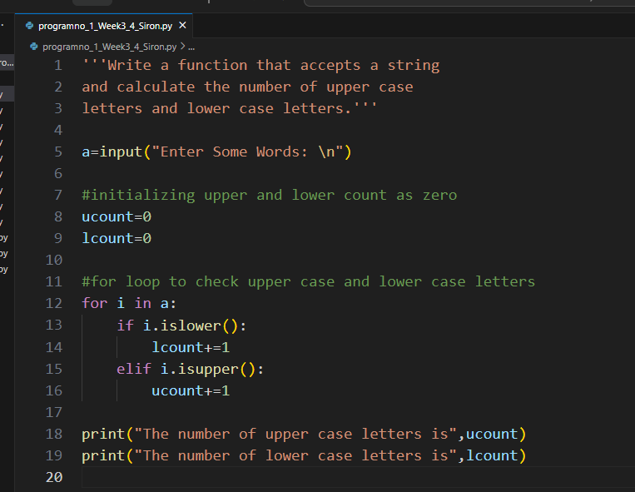

Output:
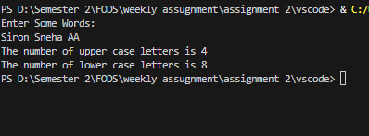
- Write a function to check whether the given number is prime or not.[format.
Answer:
#Write a function to check whether the given number is prime or not.

#taking input
print("Enter Any Number: ")
n=int(input()) #storing input in 'n' as integer

#applying if...else condition to find out prime number
if n==0 or n==1: #0 and 1 are not prime numbers
print(n,"is not a prime number")

elif n>1:
for i in range(2,n): #checking numbers from range 2 to input num
if (n%i)==0:
print(n,"is not a prime number")
break #break for loop if not prime number
else:
print(n,"is a prime number")

else:
print(n,"is not a prime number") #printing not a prime number

Screenshot:
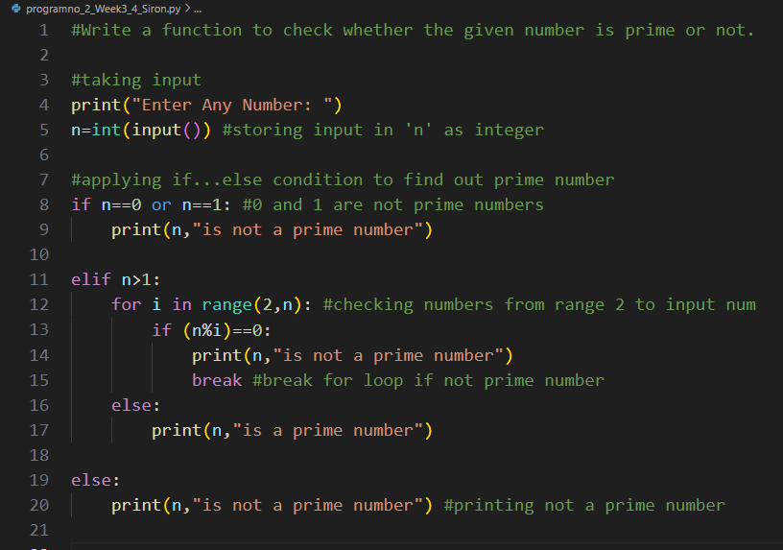

Output:
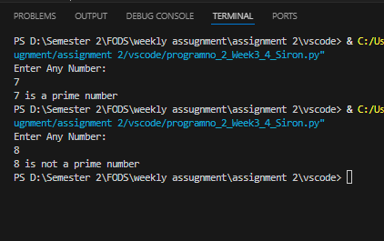

- Write a function to check whether the given number is Armstrong or not.
Answer:
Code:
#Write a function to check whether the given number is Armstrong or not

#taking input from the user
num = int(input("Enter a number: "))

sum = 0 #initializing sum

temp = num #storing num in temp variable
while temp > 0:
digit = temp % 10 #Getting the last digit of input
sum += digit ** 3 #calculating cube of last digit and added to sum
temp //= 10 #removing the last digit

#displaying the result
if num == sum:
print(num,"is an Armstrong number")
else:
print(num,"is not an Armstrong number")

Screenshot:
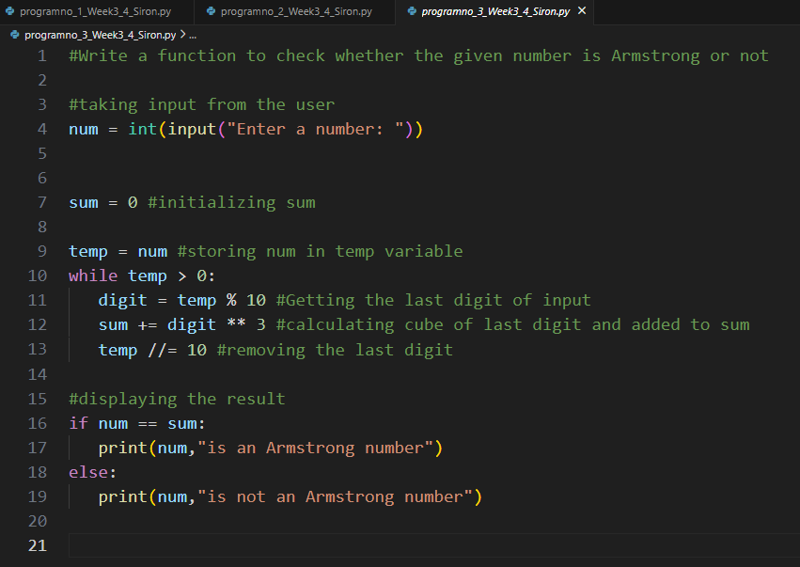

Output:
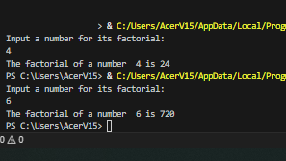

- Write a function to accept a list of names and return the sorted order of names backAnswer:
Code:
#Write a function to accept a list of names
#and return the sorted order of names back.

def List_of_names():
#taking input and storing in listinput variable
listinput = input("Enter some words separated by space; ").split()

#Sorting orders of list with ".sort()"
listinput.sort()
return listinput

#Calling the function and storing it to another variable
Sorted_order = List_of_names()

#displaying the sorted order
print("The sorted order of names are \n",Sorted_order)

Screenshot:
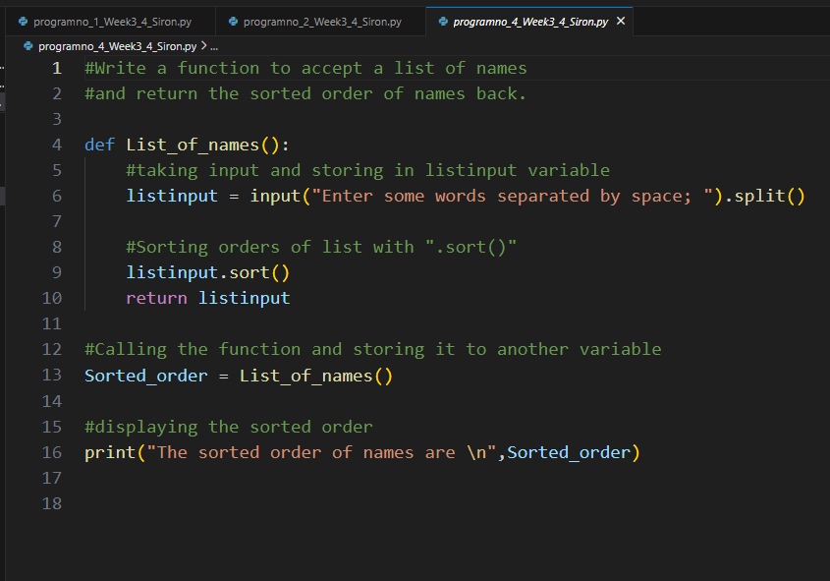

Output:
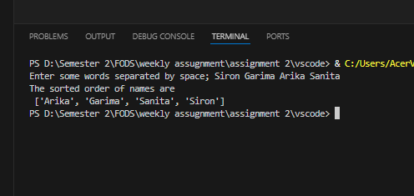

5. Create a program called calculator with functions to perform the following arithmetic calculations, each should take two decimal parameters and return the result of the arithmetic calculation in question.
A. Addition
B. Subtraction
C. Multiplication
D. Division
E. Truncated division
F. Modulus
G. Exponentiation
Answer:
Code:
'''
Create a program called calculator with functions to perform the following
arithmetic calculations, each should take two decimal parameters and
return the result of the arithmetic calculation in question.[7]
A. Addition
B. Subtraction
C. Multiplication
D. Division
E. Truncated division
F. Modulus
G. Exponentiation
'''

#Creating function for Addition
def Addition(n1,n2):
return n1+n2

#Creating function for Subtraction
def Subtraction(n1,n2):
return n1-n2

#Creating function for Multiplication
def Multiplication(n1,n2):
return n1*n2

#Creating function for Division
def Division(n1,n2):
return n1/n2

#Creating function for Truncated Division
def Truncated_division(n1,n2):
return n1//n2

#Creating function for Modulus
def Modulus(n1,n2):
return n1%n2

#Creating function for Exponentiation
def Exponentiation(n1,n2):
return n1**n2

#Creating function for the main code
def main():
#asking user for 2 input
print("\n \n \n--------CALCULATOR--------")
print("Enter any two numbers for its calculations \n \n")
n1 = float(input("The first decimal number: "))
n2 = float(input("The second decimal number: "))

#printing all the values
print("Addition : ",Addition(n1,n2))
print("Subtraction : ",Subtraction(n1,n2))
print("Multiplication : ",Multiplication(n1,n2))
print("Division : ",Division(n1,n2))
print("Truncated Division : ",Truncated_division(n1,n2))
print("Modulus : ",Modulus(n1,n2))
print("Exponentiation : ",Exponentiation(n1,n2))

#Calling the main function to run the code
main()

Screenshot: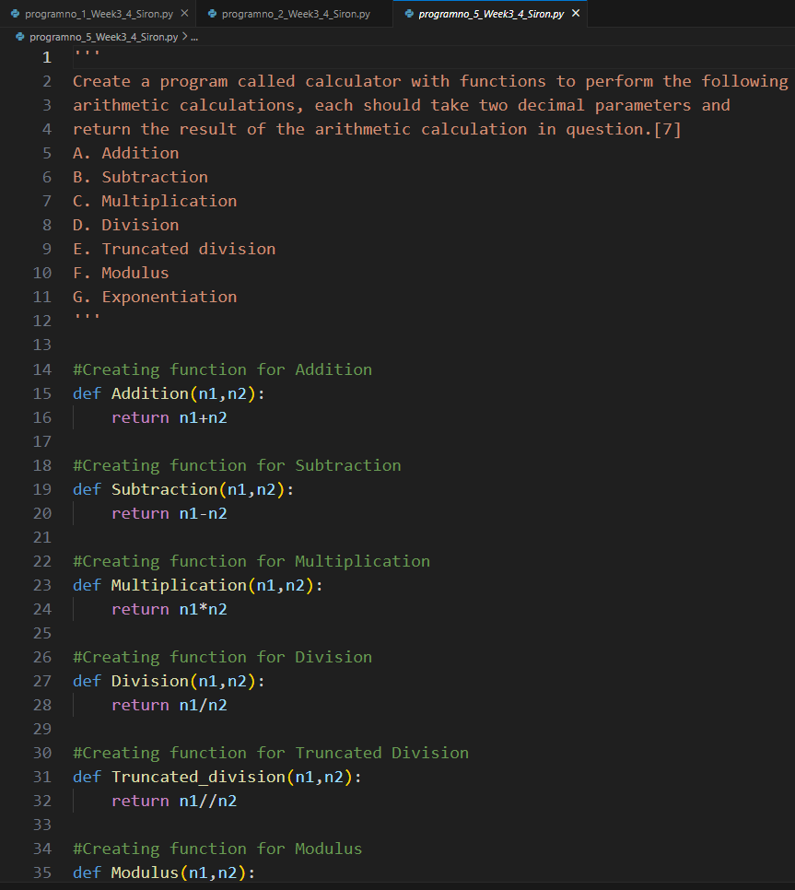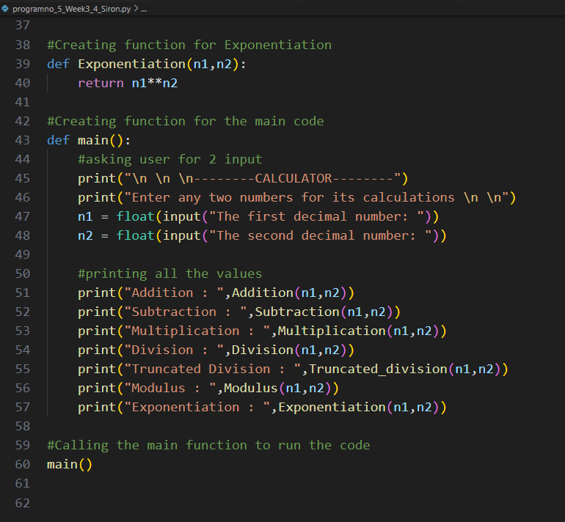

Output:
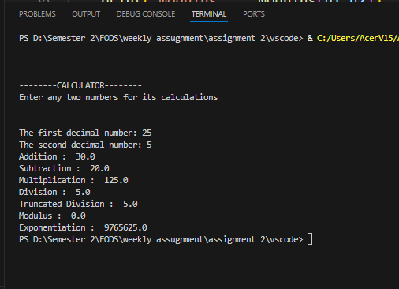

- Write a program that prompts the user for a series of integers and stores in a list only the values between 1-100, and displays the resulting list
Answer:
Code:

'''Write a program that prompts the user for a series of integers and
stores in a list only the values between 1-100, and displays the resulting list'''

def integer():
numbers = [] # List to store valid numbers
while True:
# Prompt the user for input
user_input = input("Enter a number between 1-100 or type 'exit' to finish: ")

# Check if the user wants to exit
if user_input.lower() == "exit":
break

try:
# Convert the input to an integer
inputs = int(user_input)

# Check if the number is within the valid range
if 1 <= inputs <= 100:
numbers.append(inputs) # Add valid number to the list
else:
print("The number does not lie between 1 and 100. Please try again.")

except ValueError:
# Handle invalid input (not an integer)
print("Invalid input. Please enter a valid integer.")

return numbers

def main():
display_result = integer() # Get the list of valid numbers
print("The resulting list is:", display_result)

# Run the main function
main()

Screenshot:
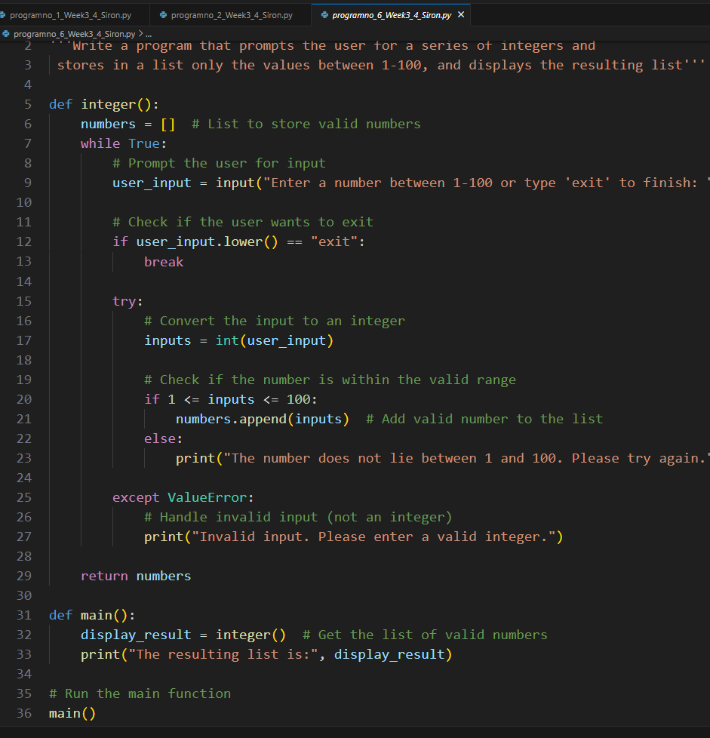

Output:
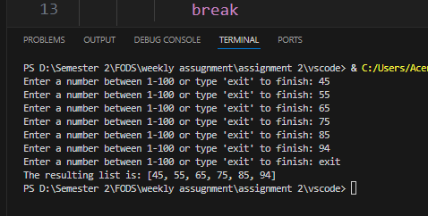

- Write a program that prompts the user to enter integer values to populate two lists, then prints messages to determine the following: [3]
(a) Whether the lists are of the same length.
(b) Whether the elements in each list sum to the same value.
(c) Whether there are any values that occur in both lists

Answer:
Code:
'''
Write a program that prompts the user to enter integer values
to populate two lists, then prints messages to determine the following:
(a) Whether the lists are of the same length.
(b) Whether the elements in each list sum to the same value.
(c) Whether there are any values that occur in both lists
'''

#Asking user for 2 inputs
print("enter integer values to populate two lists \n")
#storing inputs in 2 variable as list
list1 = list(map(int, input("1st list of integers separated by spaces : ").split()))
list2 = list(map(int, input("2nd list of integers separated by spaces : ").split()))

#displaying list 1 and list 2
print("\n \n")
print("The list 1 is",list1)
print("The list 2 is ",list2)
print("\n \n")

#Checking Whether the lists are of the same length
if len(list1) == len(list2):
print("The list are of same length")
else:
print("The list are of different length")

#Checking Whether the elements in each list sum to the same value.
if sum(list1)==sum(list2):
print("The elements in each list sum to same value")
else:
print("The elements in each list doesn't sum to same value")

#Checking Whether there are any values that occur in both lists
values = set(list1) & set(list2)
if values:
print("Value that occur in both list are ", values)
else:
print("there are no values that occur in both lists")

Screenshot:
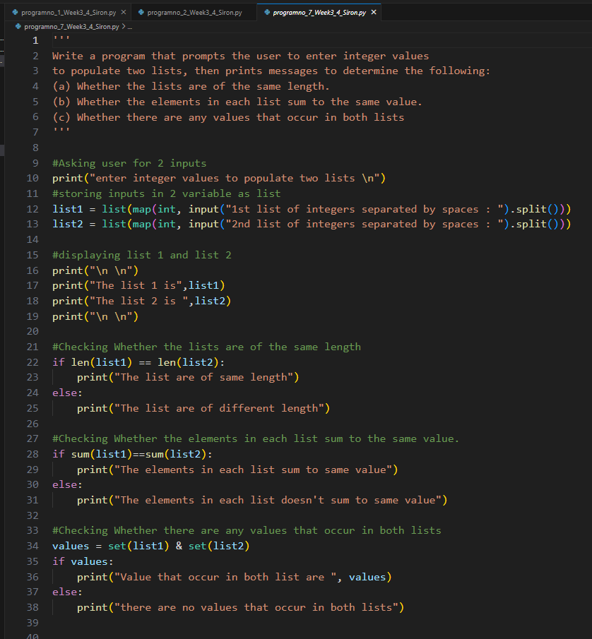

Output:
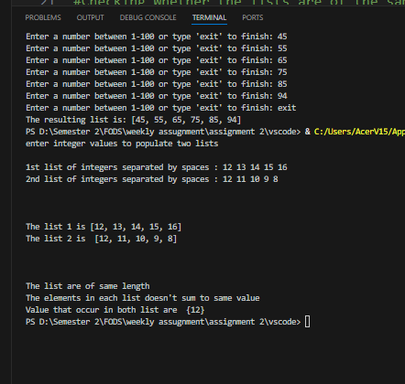

- Write a function called add_daily_temp that is given a (possibly empty) dictionary meant to hold the average daily temperature for each day of the week, a temperature value, and the day of the week for the recorded temperature. The function should then add the temperature to the dictionary only if it does not already contain a temperature for that day. The function should return the resulting dictionary, whether it is updated or not.
Answer:
Code:
'''Write a function called add_daily_temp that is given a (possibly empty)
dictionary meant to hold the average daily temperature for each day of the week,
a temperature value, and the day of the week for the recorded temperature.
The function should then add the temperature to the dictionary only if
it does not already contain a temperature for that day. The function
should return the resulting dictionary, whether it is updated or not'''

#Creating function , giving 3 parameters -- temp_dict, temperature and day
def add_daily_temp(temp_dict, temperature, day):
if day not in temp_dict: #if the day is not already in temp_dict
temp_dict[day] = [temperature]
return temp_dict #return the updated temp_dict

dict={}
n = int(input("Enter the number of inputs: "))
for i in range(n): #prompt user
day = input("Enter the day: ")
temperature = int(input("Insert temperature: "))
add_daily_temp(dict, temperature, day)
print(dict)

Screenshot:
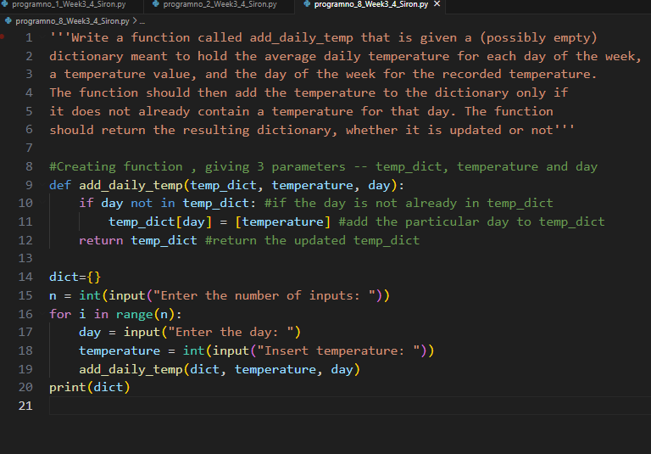4

Output:
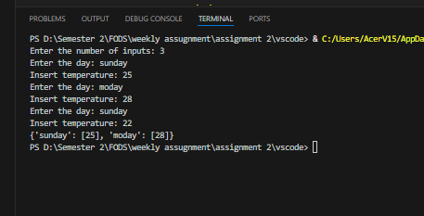

- Write a function named get_daily_temps that prompts the user for the average temperature for each day of the week and returns a dictionary containing the information the user entered.
Answer:
Code:
'''Write a function named get_daily_temps that prompts the user
for the average temperature for each day of the week and returns a
dictionary containing the information the user entered. '''

def get_daily_temps():
dict={}

for i in range(1,8):
day=input("enter day:")
temp=float(input("enter average temperature:"))
d={i:(day,temp)}
dict[day]=temp
print(dict)

get_daily_temps()

Screenshot:
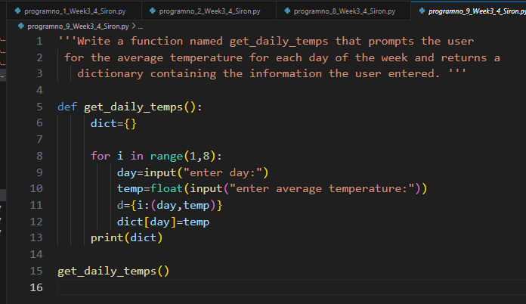

Output:
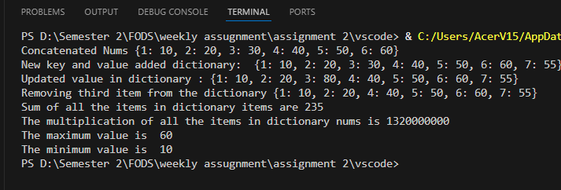

- Create three dictionaries: [7]
dic1 = {1:10, 2:20}
dic2 = {3:30, 4:40}
dic3 = {5:50, 6:60}
(a) Write code to concatenate these dictionaries to create a new one. Create a variable called nums to store the resulting dictionary.

(b) Write code to add a new key/value pair to the dictionary nums: (7, 70)
(c) Write code to update the value of the item with key 3 in nums to 80
(d) Write code to remove the third item from dictionary nums.
(e) Write code to sum all the items in the dictionary nums
(f) Write code to multiply all the items in the dictionary nums
(g) Write code to retrieve the maximum and minimum values in nums.
Answer:
Code:
'''Create three dictionaries: [7]
dic1 = {1:10, 2:20}
dic2 = {3:30, 4:40}
dic3 = {5:50, 6:60}
'''

#creating three dictionaries as in the question
dic1 = {1:10, 2:20}
dic2 = {3:30, 4:40}
dic3 = {5:50, 6:60}

#concatenating the dictionaries
nums = {**dic1,**dic2,**dic3} #creating nums variable
print("Concatenated Nums",nums) #printing concatenated dictionaries stored in num

#adding new key/value pair to the dictionary nums
nums[7]=55 #adding '7' key with value '55'
print("New key and value added dictionary: " ,nums)

#updating value of the item with key 3 in nums to 80
nums[3]=80 #updating as question says
print("Updated value in dictionary :",nums)

#removing third item from dictionary nums
del nums[3] #3rd item deleted
print("Removing third item from the dictionary",nums)

#sum all the items in the dictionary nums
sums = sum(nums.values()) #all items added
print("Sum of all the items in dictionary items are",sums)

#multiply all the items in the dictionary nums
answer = 1 #initializing answer varible as 1
for i in nums: #for loop to multiply every items
answer = answer*nums[i]
print("The multiplication of all the items in dictionary nums is",answer)

#retrieve the maximum and minimum values in nums
max_value = max(nums.values()) #finding maximum values
min_value = min(nums.values()) #finding minimum values
print("The maximum value is ",max_value)
print("The minimum value is ",min_value)

Screenshot:
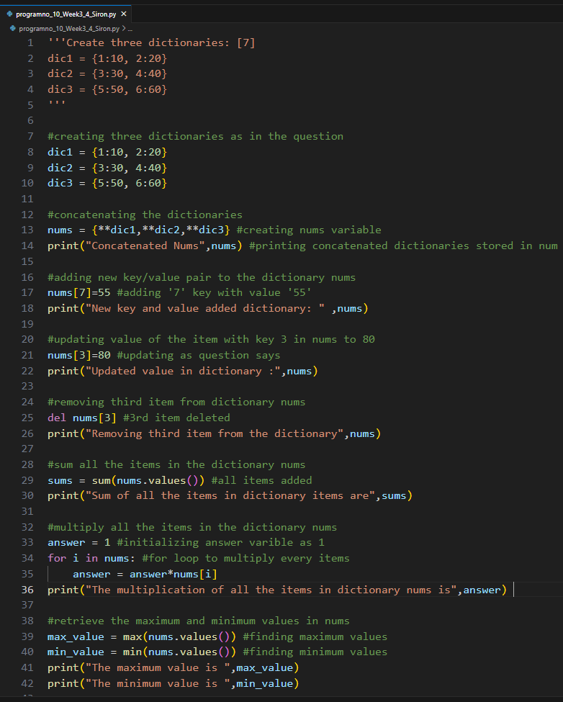

Output:


- Create two sets: [5]
set1 = {20, 40, 60}
set2 = {10, 20, 30, 40, 50, 60}
(a) Write code to perform a union of these sets. Print the length of the resulting set.
(b) Write code to perform an intersection of set1 and set2.
(c) Write code to compute the symmetric difference between set1 and set2
(d) Write code to add the value 40 to set1, did the set change?
(e) Write code to remove value 20 from set2.
Answer:
Code:
'''Create two sets: [5]
set1 = {20, 40, 60}
set2 = {10, 20, 30, 40, 50, 60}
'''

#Creating 2 sets
set1 = {20,40,60}
set2 = {10,20,30,40,50,60}
print("set1: ",set1)
print("set2: ",set2)
#displaying set 1 and 2

#Union of these sets
set_union = set1|set2 #using "|" for union of sets
print("The union of set1 and set 2 is",set_union) #displaying set 3 as union of sets

#intersection of set1 and set2
set_intersect = set1 & set2 #Using "&" for intersection
print("The intersection of set1 and set2 is ",set_intersect)

#compute the symmetric difference between set1 and set2
set_sym_diff = set1^set2 #using "^" for symmetric difference
print("The symmetric difference between set 1 and set 2 are ",set_sym_diff)

#add the value 40 to set1
set1.add(40) #adding
print("The value 40 is added so that, set1 : ",set1)
print("No, the set didn't change!!")

#remove value 20 from set2
set2.remove(20) #removing
print("After removing the value 20 from set 2 : ",set2)

Screenshot:
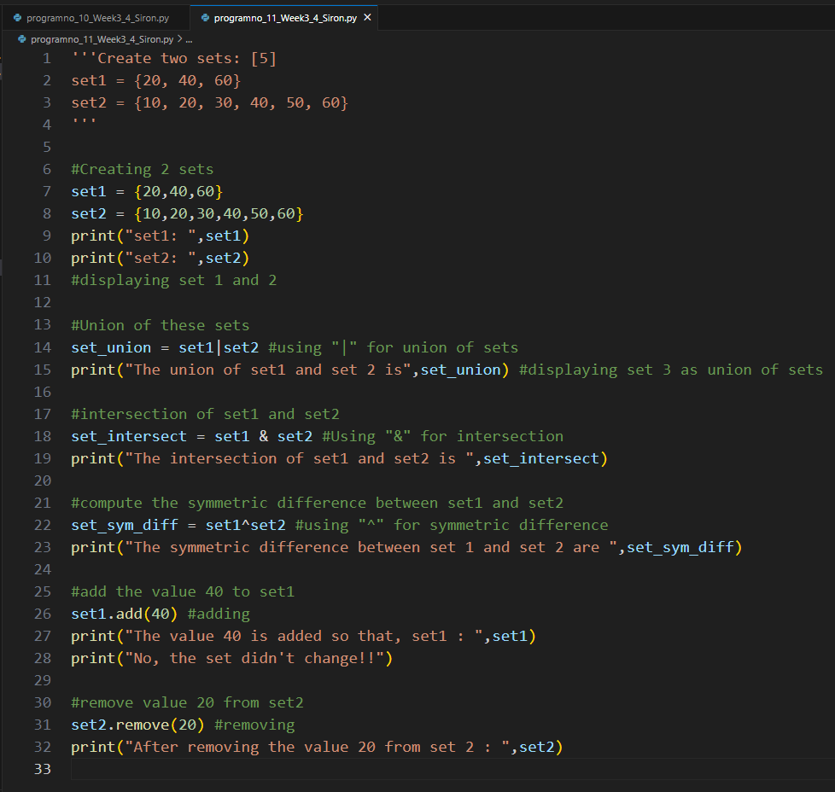

Output:
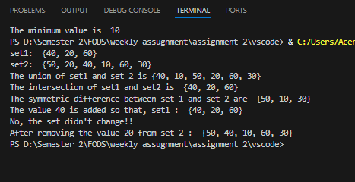

- Create a function called word_intersection that prompts the user for two English words, and displays which letters the two words have in common.
Answer:
Code:
'''Create a function called word_intersection that prompts
the user for two English words, and displays
which letters the two words have in common. '''

#Creating a funciton
def Word_intersection():
print("Enter any two English words: ")
a = input("First word: ")
b= input("Second Word: ")
#Asking user for input

#storing outcome in new variable
common_letters = set(a) & set(b)
#finding common letters by converting both variables into set

#if...else condition to print common letter if there is
if common_letters:
print("The common letters are :",common_letters)
else:
print("The two words doesn't have any word in common")

Word_intersection() #calling function

Screenshot:
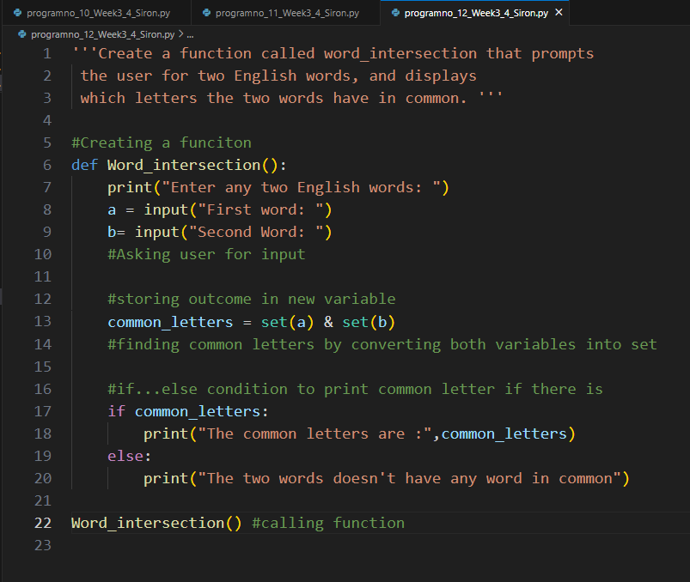

Output:
